CC Lab WEEK 4: Simple Storage Service (S3)
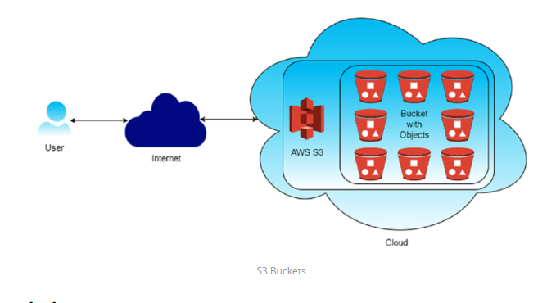1. Versioning: Versioning in Amazon S3 is a feature that allows you to keep multiple versions of an object in the same bucket. Whenever you upload a new version of an object with the same key (name) as an existing object, S3 doesn't overwrite the existing object but instead creates a new version of it. This means you can retain and access previous versions of objects, providing an additional layer of protection against accidental deletions or overwrites
- Accidental Deletion Protection:: With versioning enabled, if you accidentally delete an object, you can still retrieve previous versions of it, preventing data loss.
- Accidental Overwrite Protection::Versioning prevents accidental overwrites of objects. Even if you upload a new version of an object with the same name, the previous versions are preserved.
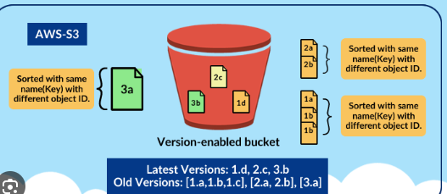
- Cross-Region Replication: Cross-region replication (CRR) in Amazon S3 is a feature that automatically replicates objects from one bucket in one AWS region to another bucket in a different AWS region. This provides redundancy and disaster recovery capabilities, ensuring that your data remains available even if an entire AWS region becomes unavailable.
- Disaster Recovery: Cross-region replication helps ensure business continuity by replicating critical data to a different geographic region, reducing the risk of data loss due to regional disasters or outages.
- Low-Latency Access: Users in different geographic regions can access data from the nearest region, reducing latency and improving performance.
- Compliance: Some regulatory requirements mandate data replication across multiple geographic regions for data sovereignty and compliance reasons.
- Event Notifications: S3 can trigger events (e.g., object creation, deletion) that can be routed to AWS Lambda, SNS, or SQS for processing.
- Integration: S3 seamlessly integrates with other AWS services such as AWS Lambda, Amazon CloudFront, AWS Glue, Amazon Athena, and Amazon EMR, enabling you to build powerful data processing and analytics workflows.

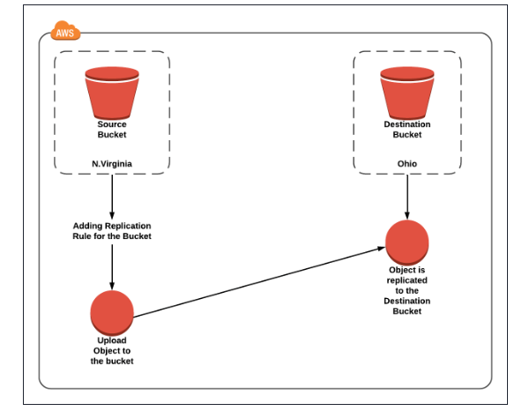

- Creating an S3 bucket, upload an object, and enable public access
1️Create an S3 Bucket (with Public Access Enabled)
Step 1: Open S3 Service
- Login to AWS Management Console
- Go to Services → S3
- Click Create bucket

Step 2: Bucket Configuration
- Bucket name: my-public-bucket-123
- Region: Choose nearest region
- ACLs enabled : enable

Step 3: Disable Block Public Access (IMPORTANT)
Under Block Public Access settings for this bucket:
❌ Uncheck Block all public access
You must uncheck ALL options:
✔ Check I acknowledge that this bucket will become public
👉 Click Create bucket
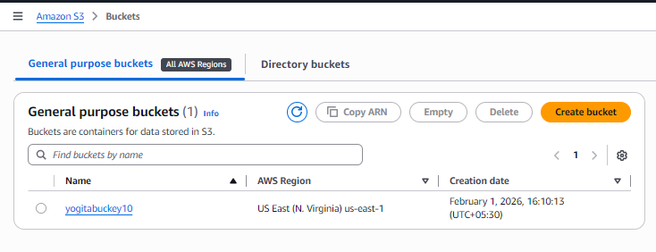

2️Enable Public Access at Bucket Level (ACL)
Step 4: Open the Bucket
- Click on the bucket name
- Go to Permissions tab

Step 5: Edit Bucket ACL
- Scroll to Access Control List (ACL)
- Click Edit
Under Public access:
- Everyone (public access) →✔ List access ✔ Read access
✔ Save changes
📌 This allows public access at bucket level
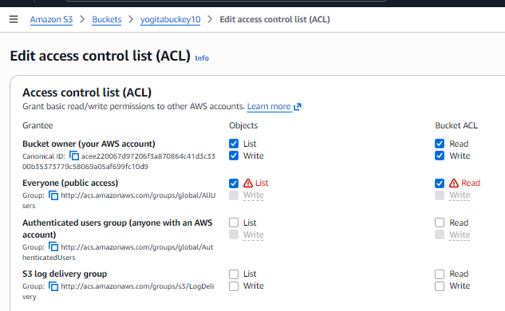

3️Upload Object to the Bucket
Step 6: Upload File
- Go to Objects tab
- Click Upload
- Click Add files
- Select file (e.g., image.jpg)
- Click Upload
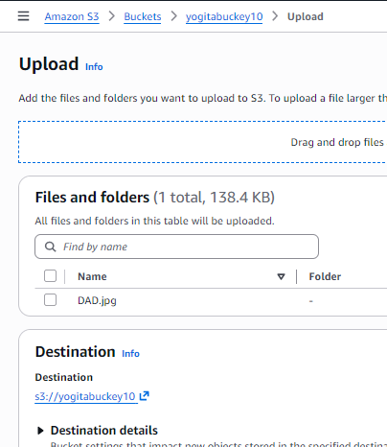

- Enable Public Access for Object (ACL)
Step 7: Object-Level ACL Permission
- Click on uploaded object
- Go to Permissions tab
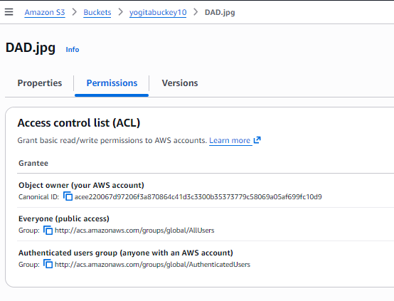
- Scroll to Access Control List (ACL)
- Click Edit
Under Public access:
- Everyone (public access) → ✔ List access ✔ Read access
✔ Save changes
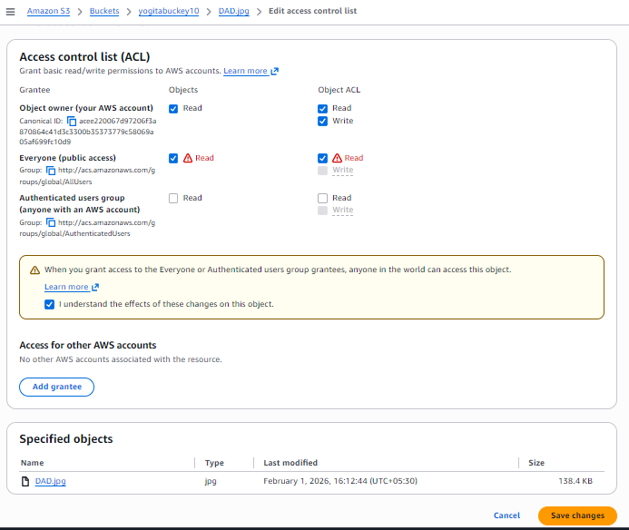

5️Verify Public Access
Step 8: Test Object URL
- Copy Object URL
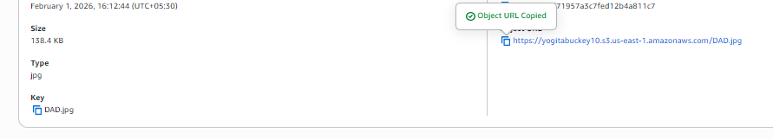
- Open in browser (incognito) (press: Ctrl+Shift+N or click the browser's menu (three dots) and select "New incognito window" )
✔ Object should be accessible without login

B. S3 Versioning & Cross-Region Replication

1️Enabling Versioning in S3 (with Output Scenario)
🔸 Objective
To enable version control on an S3 bucket and observe object versions.

🔸 Steps to Enable Versioning
- Open AWS Management Console
- Navigate to S3
- Select the bucket
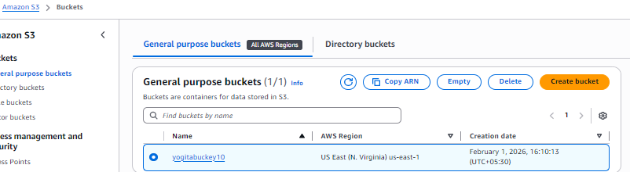

- Go to Properties tab
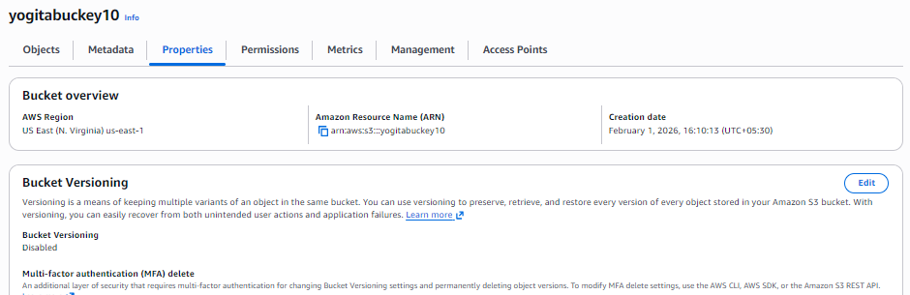

- Scroll to Bucket Versioning
- Click Edit
- Select Enable
- Click Save changes
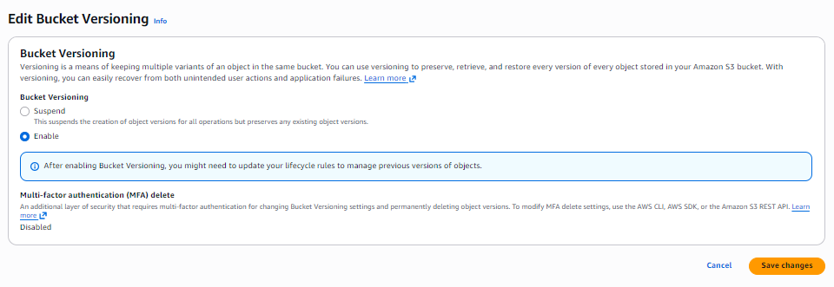
✔ Versioning is now enabled

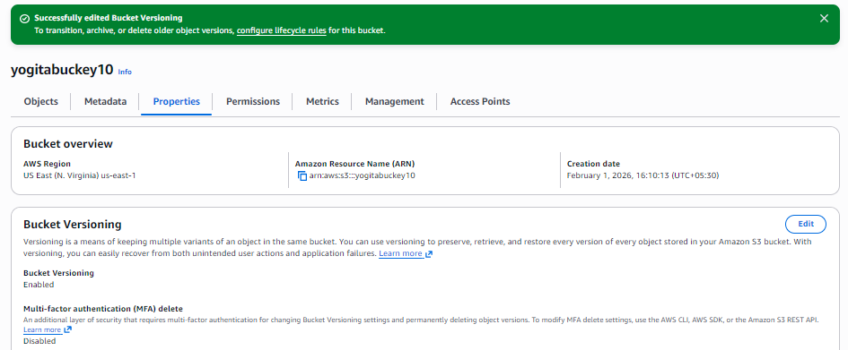

🔸 Output Scenario (What You Observe)
Step A: Upload Object
- Upload file: temp.docx
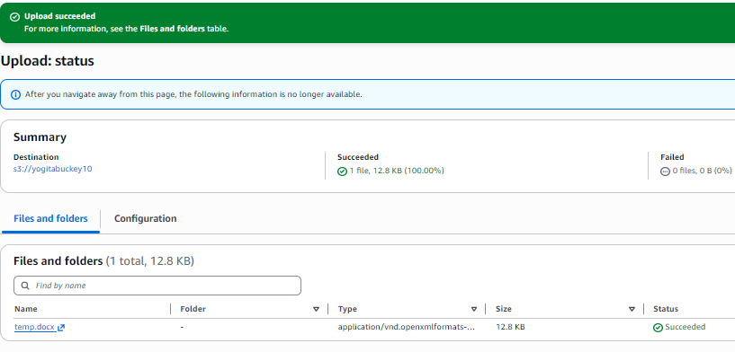
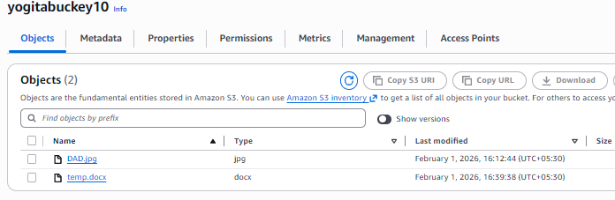
📌 Output:
- Version ID is assigned automatically
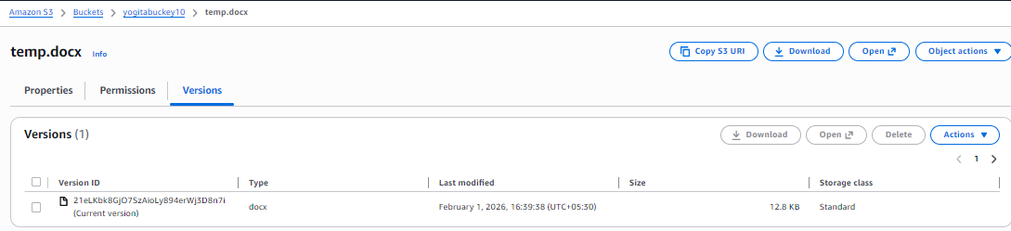

Step B: Modify and Re-upload Same Object
- Upload temp.docx again (same name)
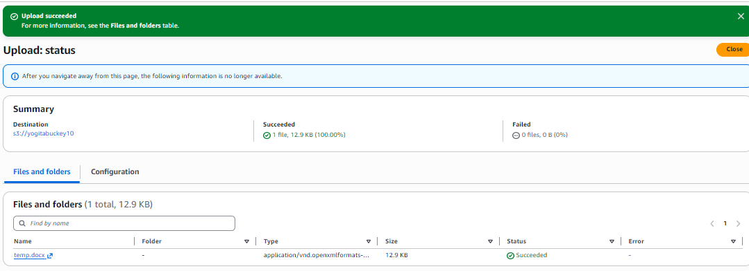

📌 Output:
- Old version is preserved
- New version becomes current
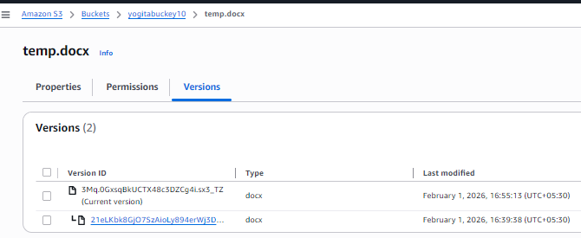

Step C: Delete Object
- Click Delete on temp.docx
- 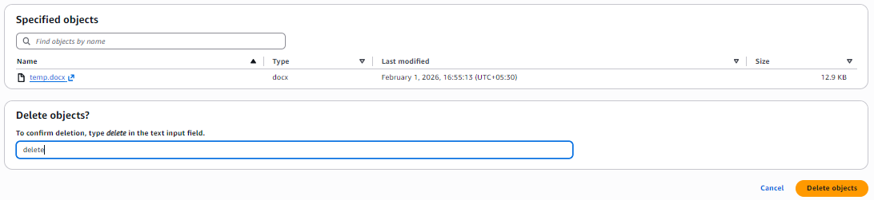
📌 Output:
- Object appears deleted
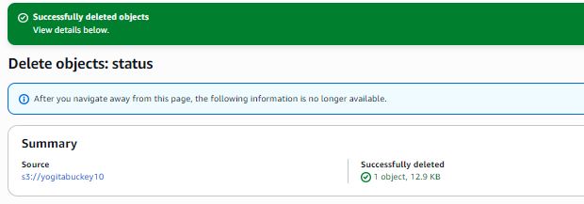
- A Delete Marker is created
- Older versions still exist and can be restored
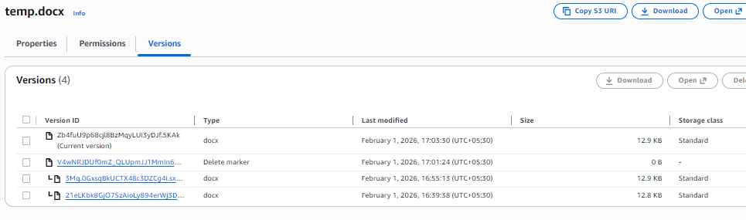
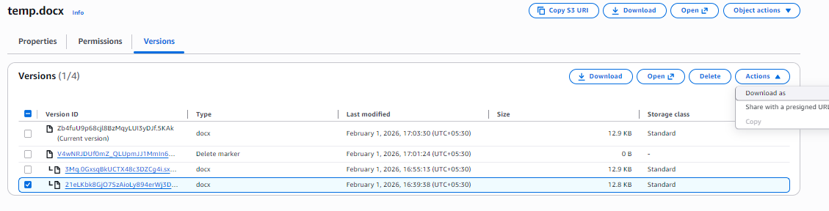
Downloads old version as below
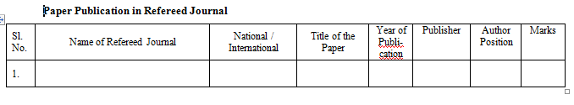
Downloads new version as below

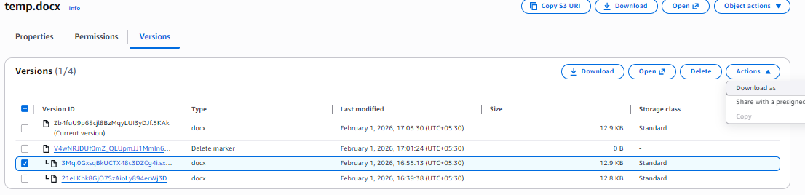

2️Cross-Region Replication (CRR)
🔸 Objective
To replicate objects from one bucket to another in a different region using AWS-managed permissions.

🔸 Prerequisites (Very Important)
✔ Versioning must be enabled on both buckets
✔ Source and destination buckets must be in different regions
✔ AWS Academy automatically handles replication permissions

Step 1️⃣ Create Destination Bucket
- Go to S3 → Create bucket
- Bucket name: dest-crr-bucketyogita
- Select different region
- Complete bucket creation
- Enable Versioning (same steps as above)

Step 2️⃣ Create Replication Rule (Without IAM Selection)
- Open Source bucket
- Go to Management tab
- Click Replication rules
- Click Create replication rule

Step 3️Configure Replication Rule
- Rule name: academy-crr-rule
- Status: Enabled
- Scope: Apply to all objects // select it
- 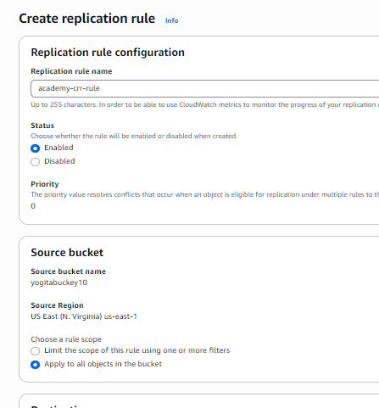

Step 4️⃣ Choose Destination Bucket
- Select Another bucket
- Choose Destination bucket
- Confirm different region
- IAM role -- as existent role and select LabRole
- Save/Next
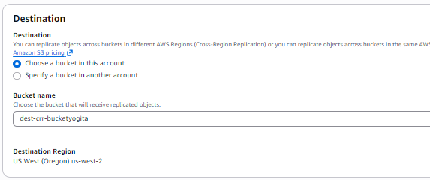
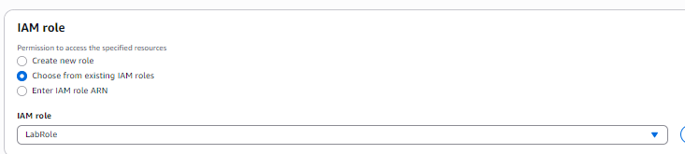
📌 AWS Academy Note:
You will see an option like:
"AWS will create and manage the required permissions automatically"
✔ Select Use AWS-managed role / default role

Step 5️⃣ Replication Options
- Replicate:
  - ✔ New objects
  - ❌ Existing objects (optional, depends on Academy permissions)
- Encryption: Leave default
- 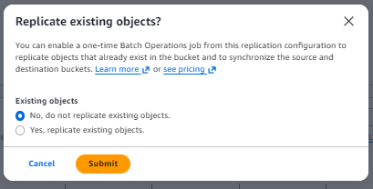
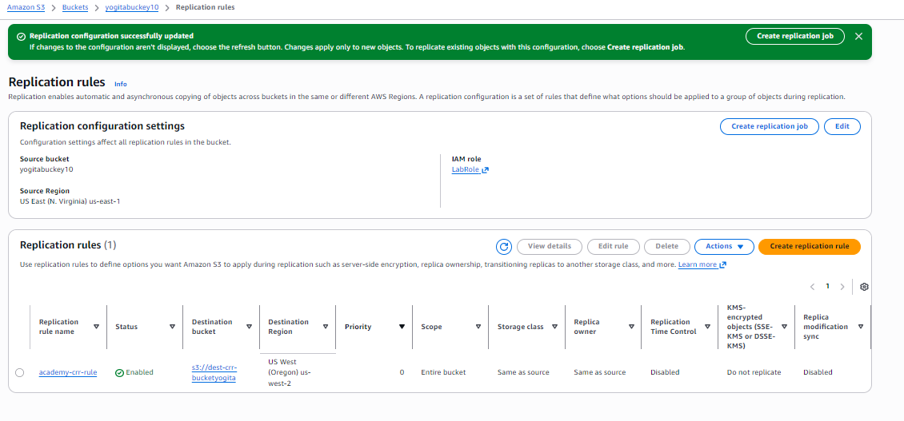

Click Save
✔ Replication rule is now active

3️CRR Output Scenario (What You Observe)
🔸 Step A: Upload New Object to Source Bucket
- Upload file: th.png
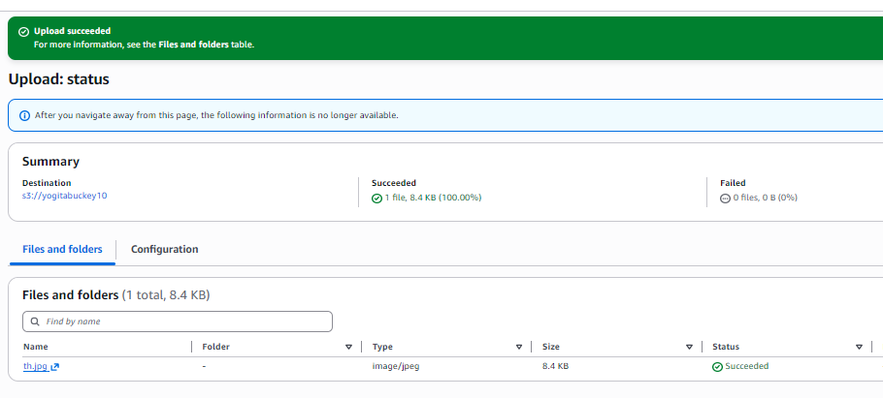
📌 Output:
- Object is uploaded normally

🔸 Step B: Verify Destination Bucket
- Open destination bucket
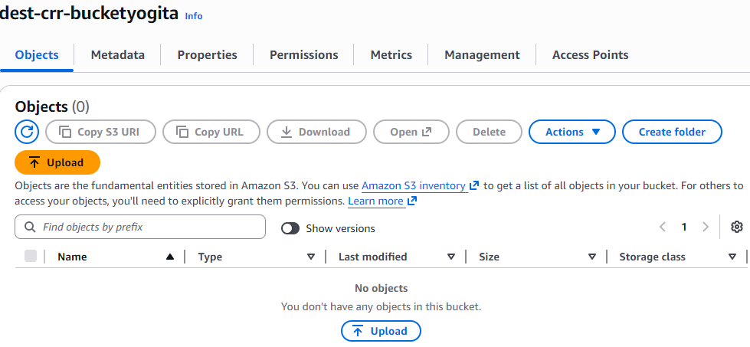
- Object image.png appears automatically
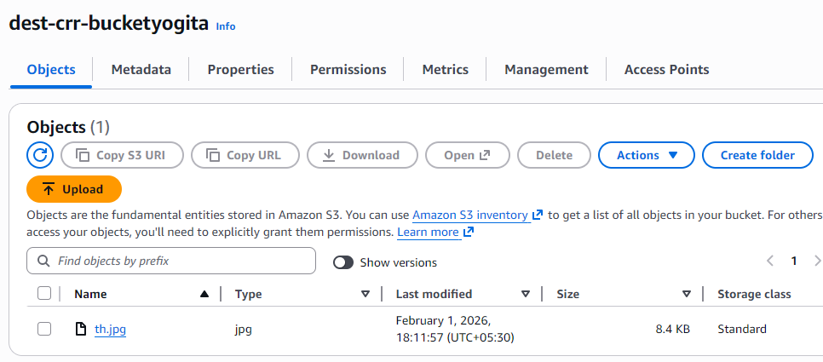
- Version ID is present
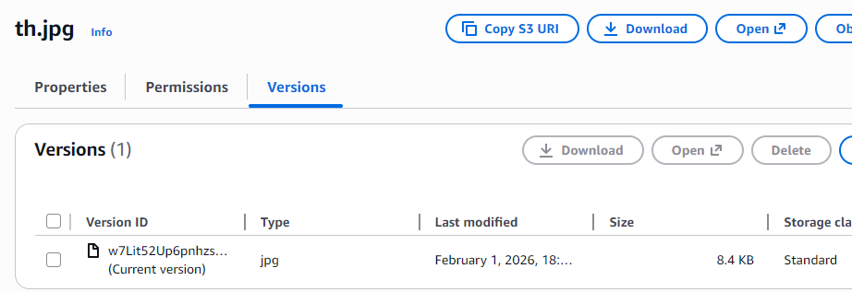
✔ Replication successful

    - Static Website Hosting in S3
(Using Bucket-Level & Object-Level Permissions – ACL Method)

🔹 Objective
To host a static website in Amazon S3 using index.html and error.html, and allow public access using ACL-based bucket and object permissions.

🔹 Prerequisites
- AWS / AWS Academy account
- Two files:
  - index.html
  - error.html

1️Create an S3 Bucket
- Login to AWS Management Console
- Go to Services → S3
- Click Create bucket
- Enter:
  - Bucket name: my-static-site-bucket-123
  - Region: Nearest region
- Under Block Public Access:
  - ❌ Uncheck Block all public access
  - ✔ Acknowledge the warning
- Click Create bucket
✔ Bucket created successfully

2️Upload Website Files
- Open the bucket
- Go to Objects tab
- Click Upload
- Click Add files
- Select:
  - index.html
  - error.html
- Click Upload
✔ Files uploaded

3️Enable Static Website Hosting
- Go to Properties tab
- Scroll to Static website hosting
- Click Edit
- Select Enable
- Choose Host a static website
- Enter:
  - Index document: index.html
  - Error document: error.html
- Click Save changes
✔ Static website hosting enabled

4️Enable Bucket-Level Public Access (ACL)
🔹 Purpose
Allows public users to access objects inside the bucket.

- Go to Permissions tab
- Scroll to Access Control List (ACL)
- Click Edit
- Under Public access:
  - Everyone (public access) → ✔ Read
- Click Save changes
✔ Bucket-level public read access enabled

5️ Enable Object-Level Public Access (ACL)
Steps (For Each File)
- Go to Objects tab
- Click on index.html
- Go to Permissions
- Scroll to Access Control List (ACL)
- Click Edit
- Under Public access:
  - Everyone (public access) → ✔ Read
- Save changes
🔁 Repeat the same steps for error.html
✔ Object-level public access enabled

6️ Access the Static Website
- Go to Properties
- Scroll to Static website hosting
- Copy the Bucket website endpoint
- http://my-static-site-bucket-123.s3-website-region.amazonaws.com
- Paste into browser
✔ index.html page loads successfully

7️ Error Page Output Scenario
🔹 Test Error Page
- Open an invalid URL:
- http://bucket-name.s3-website-region.amazonaws.com/invalid.html
📌 Output:
- error.html page is displayed
✔ Error page working correctly

Scenario-Based Questions
- A developer uploads an object to an S3 bucket but cannot access it from the browser, even though the bucket exists. What permission-related issue could be the cause?
- An S3 bucket policy allows public read access, but a specific object inside the bucket is still not accessible. Why might this happen?
- A bucket has no bucket policy, but individual objects have public ACLs. Will users be able to access those objects? What determines the final access decision?
- A company wants to ensure no public access to any object in an S3 bucket, even if someone mistakenly applies a public ACL. What S3 feature should be enabled?
- You attempt to create an S3 bucket named my-company-data but receive a naming error. What S3 bucket naming rules might have been violated?
- Two different AWS accounts try to create a bucket named project-backup-2026. One succeeds, the other fails. Why?
- You enabled static website hosting on an S3 bucket and uploaded files, but accessing the website URL returns 403 Forbidden. What is the most likely cause?
- Static website hosting is enabled, but accessing the root URL shows an error saying index.html not found. What is the actual issue?
- What HTTP error is returned when the index document is missing in S3 static website hosting, and why does this happen?
- A bucket policy allows public access, but static website hosting still doesn’t work. What object-level setting must also be verified?
- You accidentally overwrite an important object in S3. Versioning was enabled earlier. How can the original file be recovered?
- A user deletes an object from a versioned S3 bucket. Is the data permanently removed? Explain what actually happens.
- You enabled Cross-Region Replication (CRR) on a bucket, but objects are not replicating. What configuration might be missing?
- After enabling CRR, only newly uploaded objects are replicated, but old objects are not. Why?
- A company wants to replicate S3 data to another region for disaster recovery and compliance. What are the key prerequisites for enabling CRR?

